Project Design Phase-II
Technology Stack (Architecture & Stack)

Date | 18February 2026
Team ID | LTVIP2026TMIDS83223
Project Name | Shopez-one stop shop for Online Products
Maximum Marks | 4 Marks

Technical Architecture:

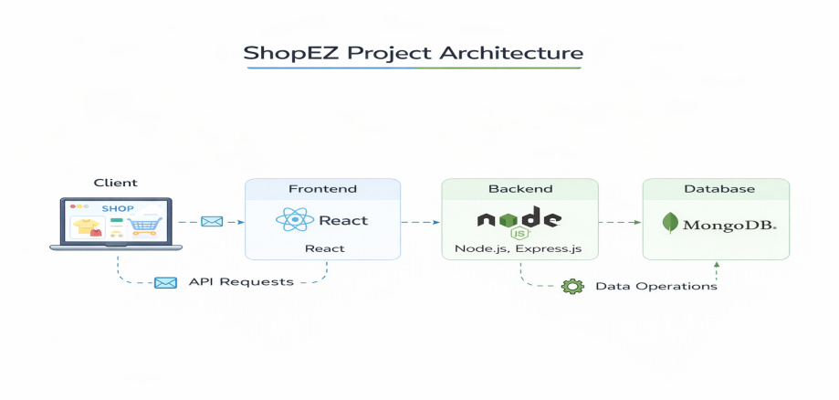

Table-1: Components & Technologies:
S. No | Component | Description | Technology
1 | User Interface | Web application for users & admin (product browsing, cart, dashboard) | React.js, HTML5, CSS3, JavaScript
2 | Application Logic-1 | Authentication & Authorization (Login, Register, JWT validation) | Node.js, Express.js, JWT, bcrypt
3 | Application Logic-2 | Product Catalog Management (Add, Edit, Delete products) | Express.js, REST APIs
4 | Application Logic-3 | Cart & Order Processing Logic | Node.js, Express.js
5 | Database | Stores Users, Products, Cart, Orders | MongoDB, Mongoose
6 | Cloud Database | Cloud database hosting | MongoDB Atlas
7 | File Storage | Product image storage | Cloudinary
8 | External API-1 | Payment Gateway Integration (Future Enhancement) | Stripe API / Razorpay API
9 | External API-2 | Email Notification Service (Optional) | Nodemailer
10 | Machine Learning (Future) | Product Recommendation System | Recommendation Algorithm
11 | Infrastructure | Application Deployment | Localhost (Development), Render / Vercel / AWS (Production)

Table-2: Application Characteristics:
S. No | Characteristic | Description | Technology
1 | Open-Source Frameworks | MERN Stack implementation | React.js, Node.js, Express.js
2 | Security Implementation | Password hashing, JWT authentication, role-based access | bcrypt, JWT, CORS
3 | Scalable Architecture | 3-Tier Architecture (Frontend–Backend–Database) | REST Architecture, MongoDB
4 | Availability | Cloud-based hosting with high uptime | MongoDB Atlas, Cloud Hosting
5 | Performance | Fast API response and optimized database queries | Express Middleware, Indexed MongoDB

